- Use of e-Leave Module
2.3 Leave Summary
2.3.1 Usage of Leave Summary
2.3.1.1 Press [Leave Summary]
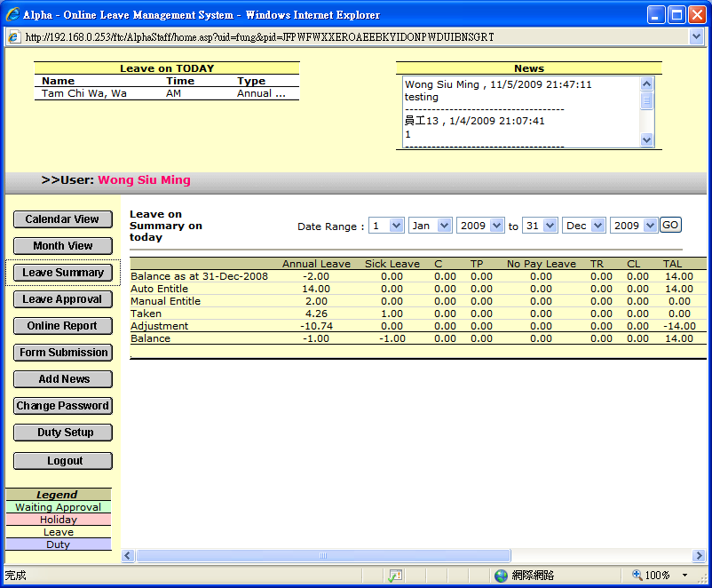

2.3.1.2 Follow Detail will be show

Item | Usage | Sample
Balance as at dd-mm-yyyy | Display previous balance | 10.50
Auto Entitle | System entitlement within selected period | 2.00
Manual Entitle | Manual entitlement within selected period | 1.00
Taken | Leave taken within selected period | 4.00
Adjustment | Leave Adjustment within selected period | -8.00
Balance | Balance Bought Forward | 1.50

2.3.1.3 Select a suitable date range before using this Leave Summary

